**Memory**

When we talk about memory in a computer, we are referring to the area from which the CPU fetches instructions or data (reading) and to which data and instructions are written (writing). It is distinctly different from storage, which is technically an external device which receives data from memory and from which data is read into memory.

Here’s a picture of a memory module for a desktop computer:

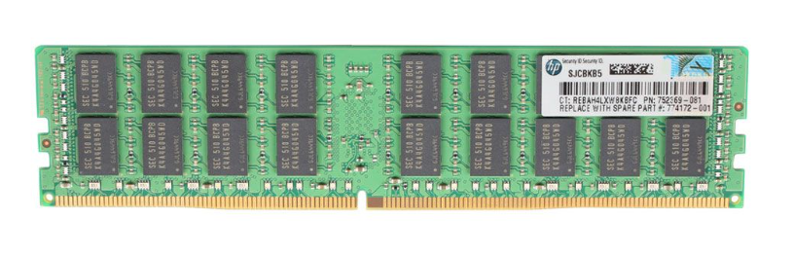

This is described as a ‘16GB (1x16GB) PC4-17000P 2133MHz ECC 288Pin RDIMM’ memory module.

What does this mean?

**16GB** – This memory module has 16GB of capacity, that is around 16 million megabytes, which is 16,000,000,000 bytes, or 128 billion 1s or 0s. Note how there are 16 chips on the image – each chip contains 1GB of storage.

**1 x 16GB –** In this context means that the memory is one-sided. Some memory modules have chips on both sides – this one has all the chips on one side.

**PC4-17000P** – This is the serial number and has no meaning.

**2133MHz** – This is the speed at which the memory runs, 2,133,000,000 signals per second.

**ECC –** This is a special format, **Error Correcting Code**, which uses a version of parity bits to check and self-correct errors in reading or writing.

**288Pin –** This is simply a description of the physical format of the memory module.

**RDIMM –** This is a special sort of memory that has registers on the memory module itself rather than just in the CPU. This means that we can ‘buffer’ or ‘cache’ data in the register for faster access than drawing the data out from the main storage on the module.

This is a 2XR4-rank chip. While ranks won’t be in the exam, if you want to know more, read this thread:

<https://superuser.com/questions/1210400/what-does-32gb8gbx4dr-mean-in-the-dumped-ram-info>